MOORCROFT MEDICAL CENTRE
Integrated with North Staffordshire Combined NHS Healthcare Trust

Easy Read Privacy Notice

Surgeries, like MOORCROFT MEDICAL CENTRE have to keep information about people. It is law that the organisations must keep information safe and secure. We tell you about this in a Privacy Notice.

This privacy notice explains how we use any information we collect about you, how you can tell us if you prefer to change the way that we use your information and your rights about the information we have about you.

Your rights about your personal information

This privacy notice explains how you can tell us if you prefer to limit the use of your information and what things we have in place here at the practice to look after your privacy.
Information about you that we may keep

MOORCROFT MEDICAL CENTRE will keep information about you to make sure that we can take the very best care of you.

Information about you that we may keep

MOORCROFT MEDICAL CENTRE keep information such as:
- Your personal details e.g. name, address, date of birth, telephone number etc.
- Any health problems that you have.
- Any medicine or tablets that you need to take to keep you well.
- The things that you like or dislike when you come to our practice.

Information about your health that we will keep

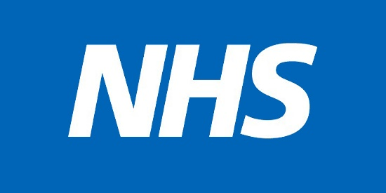

MOORCROFT MEDICAL CENTRE will use your health information to:

- Choose the right support, care, and services that you might need to help you.
- Keep you safe and healthy.
- Help you find the right treatment.

MOORCROFT MEDICAL CENTRE must follow the law when collecting, storing, or sharing information about you.

How we keep your information safe

MOORCROFT MEDICAL CENTRE will always keep your information private and safe.

The only people that we will let see your information are:

- People with permission like a member of your family who will support and help you to understand your records.

- People who have the right to see it by law.

People or organisations who may have a legal reason to see your information

These include:
- People who work in the health care service, such as doctors, nurses, therapists, social workers, pharmacists etc.
- Your local council.
- The police or security services.

How long we keep your information for:

- The amount of time we keep your information will be in line with how long the law says we must keep it for. Your health records will be kept for your whole lifetime and then for 10 years after you die.
- The amount of time we keep your information will depend on why it was needed in the first place.

You have these rights when it comes to your information:
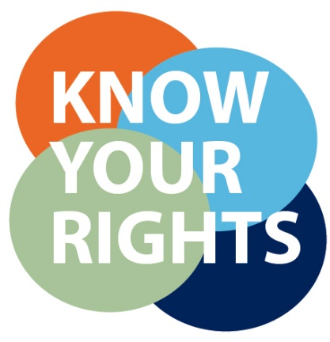
- The information we keep about you is yours.
- We will make sure it is kept private and is only used properly.
- You can ask to see a copy of the information we have about you.
- If you think the information, we have about you is wrong, or has parts missing, you can ask us to correct it.

- If you think we have information about you that is no longer needed you can ask us to delete it. (But we will not be able to delete it if the law says it is still needed).

You can ask us to stop some of the ways that we use your information, even if you do not want your information deleted.

You can ask us to delete your information by withdrawing consent (consent is when you gave us the permission to use your information).

You can ask us not to use your information for legitimate interests (This means we have a clear reason or goal for doing something).

If we cannot do what you have asked us to do, or you need help then you can contact the Data Protection Officer. Our Data Protection Officer is called

Sahra Smith and you can contact her using the below details:

Address: North Staffordshire Combined Healthcare NHS Trust
Lawton House
Bellringer Road
Stoke-on-Trent
ST4 8HH

Tel: 0300 123 1535
E-mail: DPO@combined.nhs.uk

If you are not happy in any way with how we have handled your information you can talk to us as the Practice. We will listen carefully to your concerns and try and help you as much as we can to

If you are still unhappy you can contact the Information Commissioner’s Office, who are there to help you with any problems about the way your information is used:

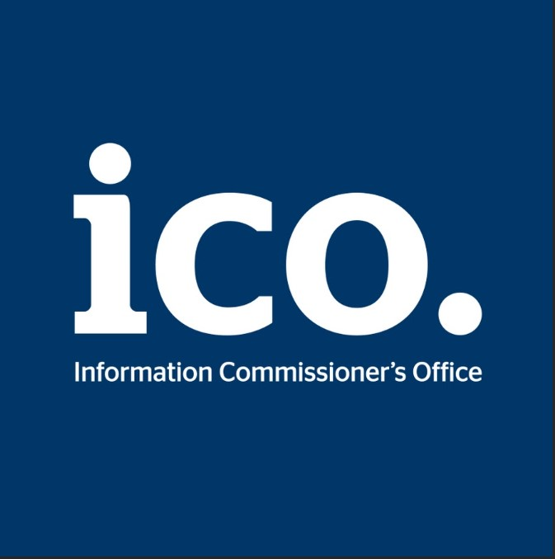

Call their helpline on 0303 123 1113 or look at their website https://ico.org.uk/

